Our EQE equipment features

- EQE testing system specifically developed for multi-junction tandem solar cells
- High precision wideband
- Light-gathering system design: The light-gathering efficiency can reach over 70%, which helps to enhance signal strength and make measurements more stable.
- Dual lock-in amplifier: Equipped with two lock-in amplifiers, it can simultaneously monitor light intensity and measurement signals, which helps to improve measurement accuracy.
- Automatic control: The integration of computer-controlled automatic signal switchers may help reduce maintenance costs.
- Monochromator: Employs a multi-grating monochromator, which features low stray light characteristics.
- Measurement wavelength range: The measurement wavelength range of common models is 300 - 1100 nm ; our EQE system can cover 325 - 1800 nm; some systems can reach 300 - 1800 nm, and can even be extended to 300 - 2500 nm.
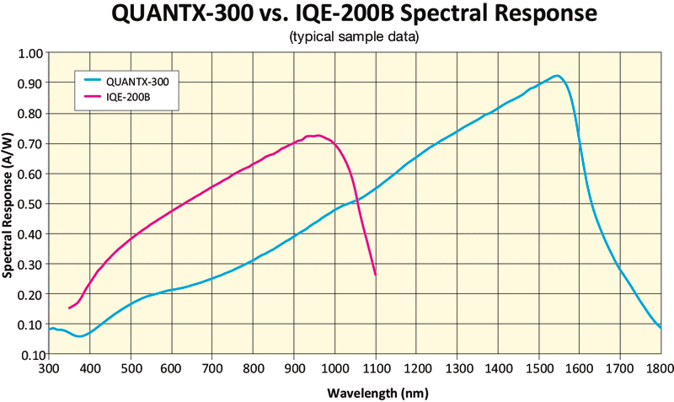
- Measurement accuracy and repeatability: Average non-repeatability ≤0.15% at wavelengths of 400-1000nm, and short-circuit current density non-repeatability ≤0.1%; in small spot mode, EQE measurement repeatability is high at wavelengths of 300-1800nm .
- Light source: Use xenon lamps, halogen lamps, or a combination of light sources, such as 75W xenon lamps and 100W quartz halogen lamps.
- System integration: The system has a high degree of integration and a compact main body size. The desktop main body houses all optical and mechanical components.
- Key metrological characteristics include: monochromatic light spot non-uniformity, bias light spectral matching degree, spectral response measurement indication error, wavelength indication error (e.g., ±0.5 nm), and temperature control platform accuracy.

B. It integrates an automated, highly matched bias light source and a sample bias voltage accessory.
- Adaptive bias light: Used to simulate carrier injection under actual operating conditions (such as sunlight), avoiding the influence of trapped states on measurement accuracy. Traditional EQE testing requires manual preparation of polarized light, which is cumbersome and prone to errors. We use a polarized light source with adjustable wavelength, intensity, and angle, which can automatically and quickly switch according to the testing requirements of stacked devices and components to ensure that each junction is in a quantum efficiency saturation state.
- Automatic bias voltage: We integrate a bias power supply that can quickly adapt to suitable parameters for studying the performance of devices under different electric fields. This is especially important for multi-junction or complex structure devices such as thin-film solar cells and perovskite/Si tandem cells, where adjusting the bias voltage to find the optimal test conditions is crucial.
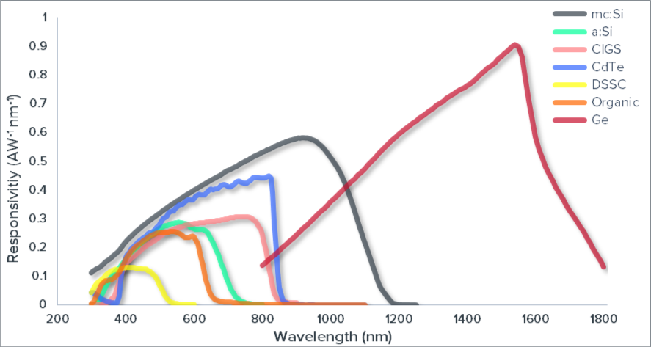
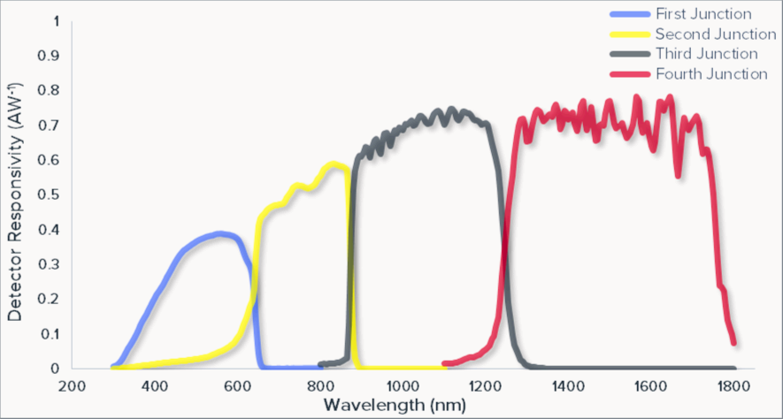( net )
- An automated testing module specifically developed for large-area components
During large-area module testing, the typical monochromatic light spot size is around 1*1mm, and the light intensity concentration is insufficient, resulting in light overflow at the edges that affects the module test. We have developed a reshaped and focused light spot specifically for module testing to accurately test individual cell parameters. Furthermore, during module testing, the system automatically scans the performance of individual cells and then sequentially switches to test moving sub-cells. The automatic testing module can more efficiently and quickly calibrate the EQE parameters of each junction of the module, while also extracting a large-area light spot for overall module-level EQE test calibration.

- Automatically calibrates AM0 and AM1.5 spectra and low-light spectra, adaptable to low-light scenarios, ground-based and space-based photovoltaic matching tests.
- High degree of automation integration, user-friendly software interface

